1. Fix immediately: errors and contradictions

Fee structure contradicts itself. This is the most serious issue, because the fee structure is your main selling point.

The homepage says you earn only when the investor does, with no flat management fees eating into capital regardless of performance.
investrright
The About page FAQ says you charge a 2% per annum management fee and a 20% performance fee above a 10% hurdle.
investrright
Neither matches the actual structure: zero management fee below 10% returns, zero performance fee below 25%, and an 80/20 split above that.
Rewrite the FAQ and add a proper fee section on the Products page.

A fund that doesn't exist. The FAQ says the minimum is ₹1 Crore for equity strategies and ₹50 Lakhs for a "Multi-Asset Diversified Fund". There is no such fund, and ₹50 lakh is below the Cat III minimum. Delete this line.
investrright

Corpus and dates don't match.

The About stats show ₹500 Cr target corpus, "Founded 2026" and "25+ Yrs" leadership bench. On the same page, the text says you began in February 2022 and the leadership has 75+ aggregate years.
investrright
The homepage also says "Est. 2026".
investrright
Suggested fix: "Est. 2022 · SEBI-registered 2026", "₹300 Cr + ₹200 Cr greenshoe", and "75+ yrs" everywhere.

Wrong email and placeholder phone numbers. Enquiries are probably being lost because of these.

The footer email is info@investright.com (single R), and the phone link dials +919876543210 while displaying 76000 82712.
investrright
On the Contact page, the email shows the correct spelling, but the mailto link still goes to investright.com.
investrright
The About page has a "Call +91 120 691 0000" button, which also looks like a placeholder.
investrright

Brand name is spelled five ways. "InvestRright", "Invest Rright", "Invest Right", "Investright" and "Investrright" all appear. Even on the Products page, the H1 says "Investright Infinity Growth Fund – I" and the card below says "Investrright". Use the exact names on your SEBI certificate and PPM everywhere.
investrright

Dead legal links. Privacy Policy, Disclaimer and Terms of Use all link to "#". Your contact form collects names, emails and phone numbers, so a real privacy policy is needed for DPDP compliance, not just as good practice.
investrright

Blog is broken. The blog is titled "Weekly Market Report", promises fund performance every week, and shows only "Loading...". Either fix it or hide it. An empty insights page looks worse than having none.
investrright

Admin and Sales logins are public. Client, Distributor, Sales and Admin logins all appear in the public navigation. Keep Client and Distributor. Move Admin and Sales to an unlisted URL. This is both a security risk and bad optics.
investrright

Wrong eligibility checkbox. The contact form asks the user to confirm they are an "accredited investor". Cat III eligibility is the ₹1 Cr minimum commitment, not accreditation. Replace it with a note that the minimum investment is ₹1 Cr, plus a data-consent line.
investrright

Unverified performance claim. The timeline says the self-funded strategy delivered ~50% YoY, with an asterisk but no footnote. SEBI requires that wherever past AIF performance appears in marketing material or the PPM, the performance-versus-benchmark report from a benchmarking agency must be provided with it. Your prop-desk record isn't the AIF's record. Have Ultiwise Legal decide whether it can appear at all, and where.
investrright
Business Standard

Smaller fixes:

The homepage market stats (8.5 lakh HNIs, ₹1.65T HNW wealth, ₹16.94T AIF commitments) have no sources. The HNW wealth figure being smaller than AIF commitments looks wrong. Cite a source for each figure or remove them.
investrright
The "Moderate" risk tag on a leveraged long-short derivatives fund needs to match what your PPM risk factors say.
The FAQ refers to "SEBI-registered custodians" generically. Name ICICI Bank.
Contact page shows only "Noida, Uttar Pradesh". Add the full Mindmill Tower address, the Jhansi and Vadodara offices, a map and office hours.
Fix grammar ("HNIs and family offices and corporates", "Every investment we execute, pass through").
Replace the old "Learn · Trade · Invest" tagline in the logo alt text.
2. Missing regulatory pages that peers have

Investor Charter and complaints data. SEBI prepared an Investor Charter for AIFs covering services, grievance redressal and investor responsibilities, and requires AIFs to compile investor complaint data in the prescribed format within 7 days of each quarter-end. ITI's long-short fund site links its Investor Charter, Stewardship Code and complaint report directly on the homepage. Add all three.
TaxGuru
Itiorg

Grievance redressal page. Abakkus explains that investors can complain in writing, by phone or in person, commits to resolving complaints within 21 calendar days, and gives dedicated service and compliance email IDs. Investors must also be told they can go to the ODR Portal if the manager doesn't resolve their grievance satisfactorily. Your page should include:
Abakkusinvest
Hdfcfund

Compliance Officer name and contact details
An escalation matrix
Links to SCORES and SMART ODR

A single "Disclosures" page. Peers use one page listing:

SEBI registration number and certificate
CIN and registered office
Sponsor, Manager, Trustee (Vistra ITCL), Custodian (ICICI Bank), RTA (Mudra), Auditor, Legal advisor
Principal Officer and Compliance Officer

Abakkus has exactly this kind of page listing all its registrations and downloadable regulatory documents.
Abakkusinvest

Eligibility gate. Many AIF sites show an "I am an eligible investor / this is not a solicitation" pop-up before fund details are visible. Since AIFs can raise money only by private placement, this is a sensible safeguard.

3. Missing content that would help conversions

Fund facts table. Right now the only term shown on the Products page is the ₹1 Crore minimum. Add a full table:
investrright

Structure (open-ended)
Fees, hurdles, high-water mark
Exit load: 5% before 2 years, plus the waivers
Subscription and redemption frequency, notice period
Benchmark
Leverage limits
NAV frequency. The SEBI charter requires monthly NAV disclosure for open-ended Cat III funds.
Amazonaws
Service providers

Fee illustration or calculator. Your fee model is unique, but no page explains it with numbers. Samvitti puts a fee calculator right in its main menu. A simple "what you'd pay at 8%, 15% and 30% returns" table would be your strongest page.
samvitticapital

Tax note. Cat III AIFs don't get pass-through status, and tax is paid at the fund level. HNIs will ask about this first.
BlackSwan Securities

How to invest. Add the onboarding steps: KYC, FATCA/CRS, contribution agreement, PPM acknowledgement, drawdown. Also cover NRI eligibility and a document checklist.

Richer team profiles. All profiles currently show initials instead of photos. Add:

Real photos and LinkedIn links
Prior firms for each person. ITI and Avendus give detailed career histories.
Certifications. Yours (NISM VIII, NISM XIX-C, CFA Level I) aren't mentioned anywhere.

Governance section. Show the investment committee, risk committee and trustee oversight. Institutional investors look for this.

Distributor / Partner page. You have a distributor login but no page explaining empanelment.

Other pages to add:

Media and events, including coverage of the 11 Sep launch
Careers (you're hiring a Head of Sales)
Social links
Monthly newsletter sign-up. ITI publishes monthly insight newsletters.
Itiorg

SEO. Every page uses the same OG image, and the /blog title is "Weekly Market Report". Give each page its own image and title.

One limitation: I could only read page text. I haven't checked mobile layout, page speed, or whether the login pages work.

I can turn this into a checklist doc for your web developer, or draft the replacement FAQ, fee illustration and disclosures page copy. Which would help more?

Sources:

InvestRright – Home, Products, About, Contact, Blog
ITI Long-Short Equity Fund
Abakkus Disclosures
Samvitti Capital
TaxGuru – SEBI Investor Charter & complaints for AIFs
Business Standard – SEBI AIF performance benchmarking
Investor Charter for AIFs (sample)
Black Swan Securities – AIF overview

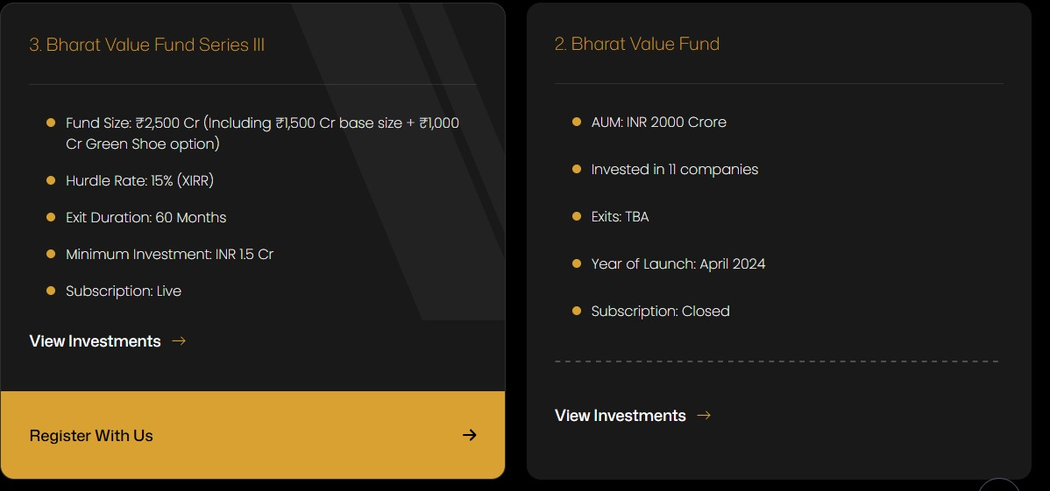

Product details should look like this, basically the point is to make it look more professional

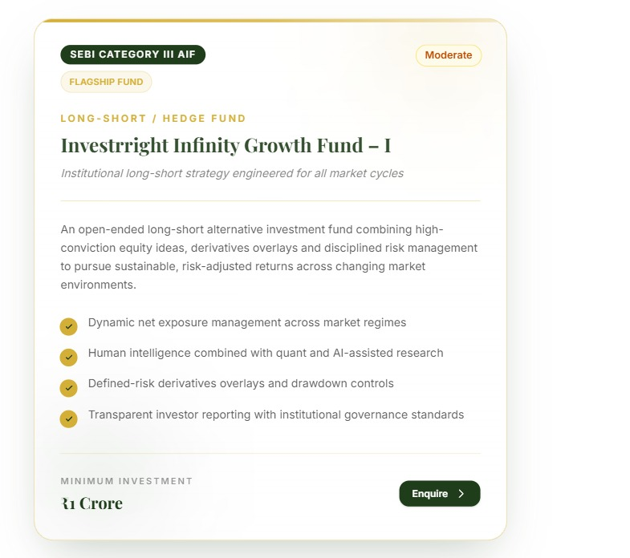

This is how currently the product looks like

fund name is InvestRight and company name is InvestRright so make changes accordingly


to be updated sending you shortly

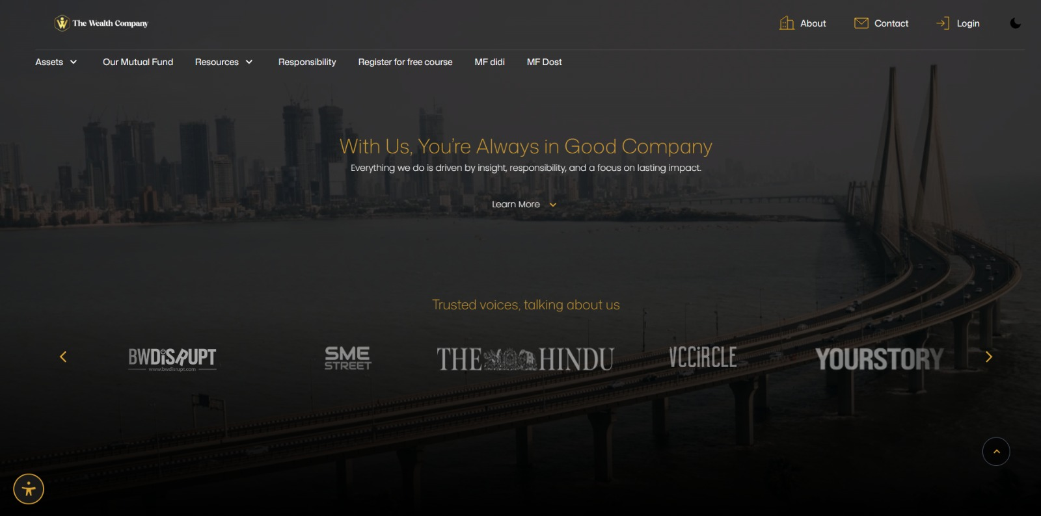

is type ki bg image share krte hai abhi

founding year different

add image of team and description



Remove this

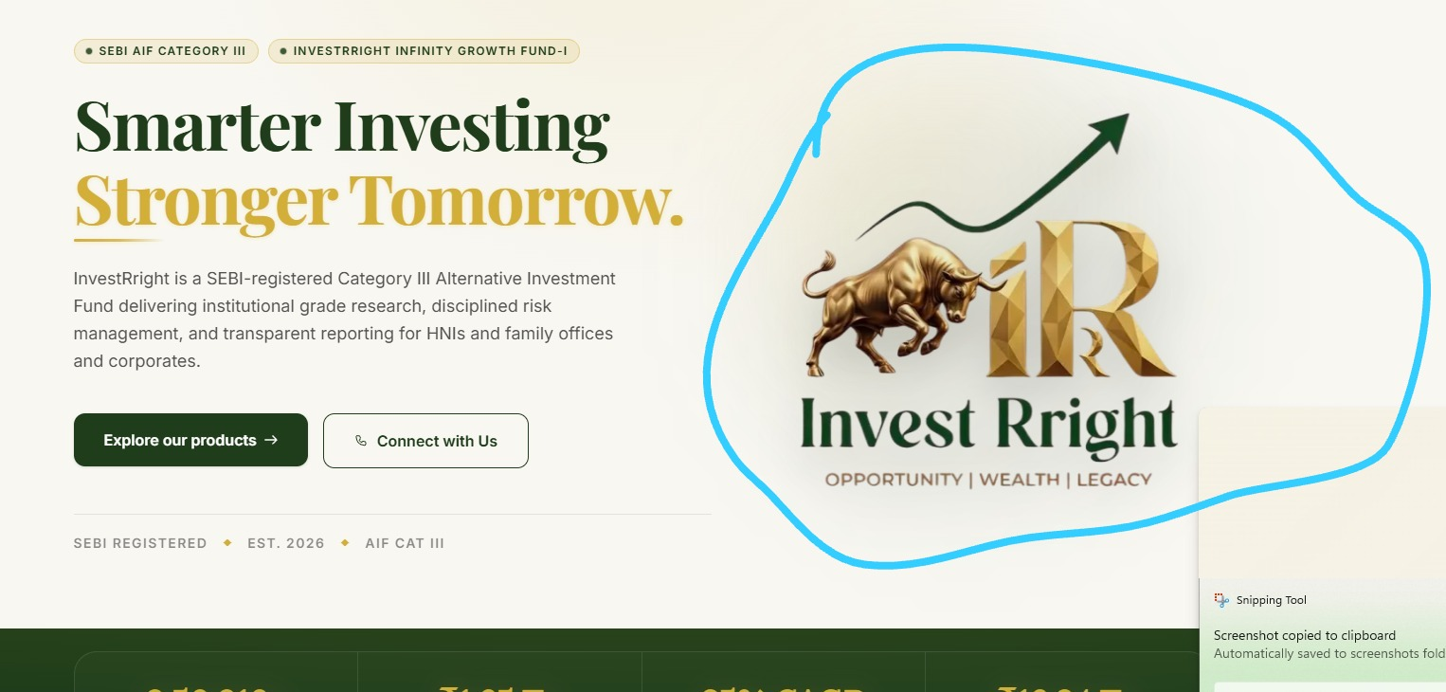

Remove this rotating logo

As of 2:02 AM to be changed

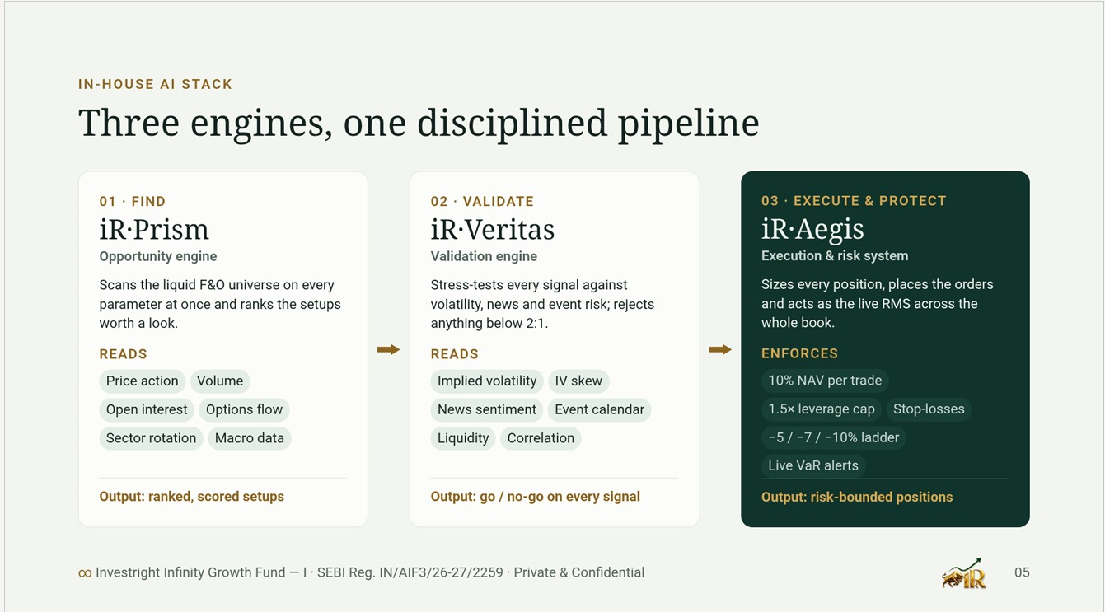

Add these as our in house logos
smarter investing, stronger tomorrow replace it to "Long-short equity, built for every market."

keep the registration no. at the header, no need to keep it multiple times.

Change the menu to Fund · Strategy · Team · Insights · Contact, plus Investor login.

how the long-short strategy works (the animated explainer fits here);
risk management framework;
leadership team with photos and credentials, which matters more than anything else for HNI trust;
how to invest in steps (KYC, then PPM, then contribution agreement, then drawdown);
service providers (trustee, custodian, RTA, auditor);
insights and blog;
a footer with disclaimers, your grievance officer and the SEBI SCORES link.

